**RESUME**

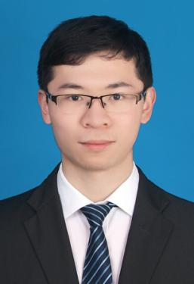

(+31)639816389

wujianwei618@gmail.com

Hoofddorp, Netherlands

Jianwei Wu

**EDUCATION**

**09/2018-10/2020 Institut supérieur d'électronique de Paris(ISEP) Master/Engineer in Embedded Systems**

Courses: Computer Fundamentals and Linux, Computer Networking, ARM, Digital Signal Processing

**09/2014-06/2018 Chongqing University Of Posts And Telecommunications Bachelor in Microelectronics Science**

Courses: C Program Language, Digital circuits, Microelectronics, Semiconductor Manufacturing, CMOSRF, EDA, FPGA

**SPECIAL SKILLS**

* Language : Native Mandarin Speaker. Fluent English in oral communication(TOEIC 805). French (A2）
* Expertise: C, C++, Java, Python, SHELL, Linux, ARM, GIT, System migration

**ABOUT ME**

* A thorough understanding of computer science and programming in order to provide professional technical support
* Detail-oriented with the ability of handling complaints by adjusting communication styles
* Passionate team leader with strong business sense and ensuring business plans are in place
* Strong desire of motivating colleagues to engage in order to achieving department goals
* Passionate about digital products (PCs, mobile phones, IoT devices）

**WORK EXPERIENCE**

**12/2023-present BYD EUROPE B.V., Hoofddorp, Netherlands Senior Software Engineer**

* Developed and maintained OTA application features for oversea platform, improving performance and user experience.
* In charge of analyzing and solving after-sale Tbox system stability problem, including network disconnection, crash, data communication loss, etc.
* In charge of development of the BYD OS framework for the new platform, perform a Rust refactoring of tbox from IVI side.

**08/2023-11/2023 BYD Auto Industry Co. Ltd., Shenzhen, China Senior Software Engineer**

* Responsible for porting Flatpak to the Linux application layer and setting up a Flatpak repository.
* In charge of development of the BYD OS framework for the new platform, perform a Rust refactoring of tbox from IVI side.

**07/2021-08/2023 Xpeng Automobile Technology Co., Ltd, Guangzhou, China Embedded Software Engineer**

* Participated in the embedded development of TBox for several vehicle models, including coding, function debugging, test case preparation, problem handling, progress control, version release, etc.
* Conducted research and development on Linux device drivers, including debugging and developing audio drivers(codec and op amp) and handling related issues.
* Responsible for technical support of eCall Europe road tests and crash tests, as well as training overseas staff on how to capture logs for problem analysis
* Responsible for the R&D of software underlying area dynamics in CDCU project based on Qualcomm 8295 chip, including the configuration of ADC channels in QNX's underlying PMIC, and the development of the tbench platform for verifying functions.

**05/2020-03/2021 Huawei, Paris, France Terminal Test Engineer**

* Verification tests on the quality of terminal products, including mobile and fixed line equipment for SFR. various test case setup and execution (manual and automated tests), quality rating, quality inspection optimization & recommendations based on certain device types
* Contacted with software engineers to solve problems in the product localization through logs analysis
* SFR and Orange version updates for most phones and routers as well as problem solving
* Huawei BetaClub (pre-release software testing)